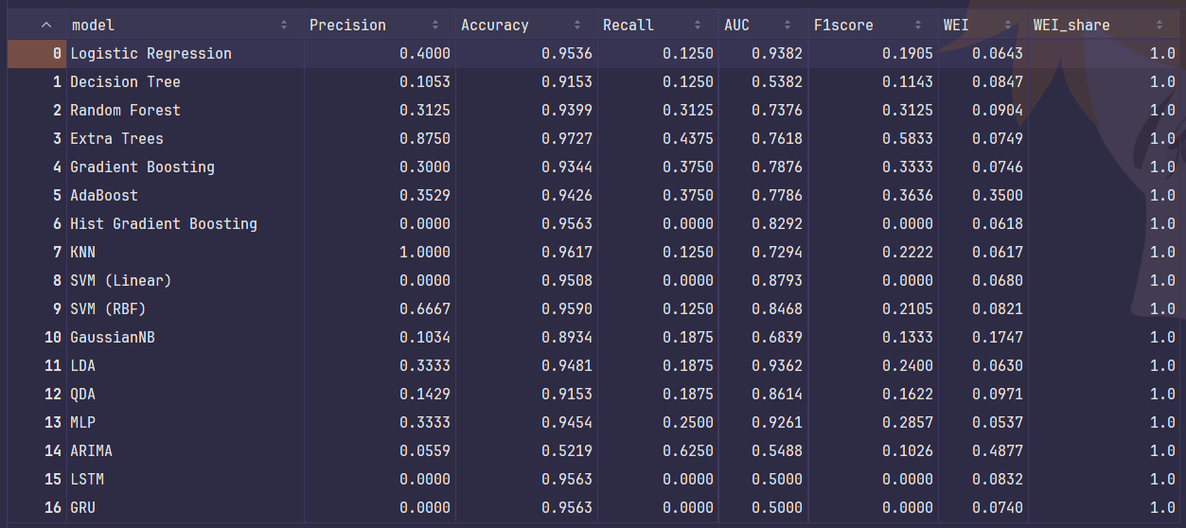Below are the raw outputs of supervised learning models on ECA

From the results and plots, we can see that the extra tree model can perform best in predicting. So, we choose to evaluate that model.

For 2024’s results, the model can achieve an average precision of 50% and an average recall of 50%. While in the previous algorithm, it cannot be evaluated on ECA, so almost every metric is 0.

|  |  |  |  |
| --- | --- | --- | --- |
|  | Original | Limited to June-September | Monte Carlo |
| Accuracy | 0 | 0 | 0.5 |
| Recall | 0 | 0 | 0 |
| Precision | 0 | 0 | 0 |

This showed that the supervised model can perform much better than the old ones.

Next, below are raw outputs of supervised learning models on RTO/TESLA

From the results and plots, we can see that the SVM (Linear) model performs best in predicting. So, we choose to evaluate that model.

For 2024’s results, the model can achieve an average precision of 75% and an average recall of 75%. For June and August, it can even achieve 100% accuracy.

|  |  |  |  |
| --- | --- | --- | --- |
|  | Original | Limited to June-September | Monte Carlo |
| Accuracy | 0.333333333 | 0.333333333 | 0.428571429 |
| Recall | 0.6 | 0.6 | 0.6 |
| Precision | 0.428571429 | 0.428571429 | 0.6 |

While in the previous algorithm, both Recall and Precision are lower than the new model. And the new model is even more accurate.

Though the models used for the datasets are different, we can find that the logistic regression model can achieve almost the second-best on both sides when evaluating normal power load, while maintaining the same precision and recall value when predicting 4CP. So, I think we can simply conclude that logistic regression is a better model in general evaluation.